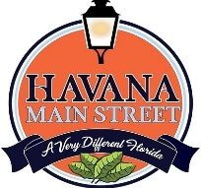
Painting in the Shade – 3rd Annual Plein Air Event
Havana Florida
CALL FOR ARTISTS
May 18 - 20, 2023
Deadline: April 28, 2023
Send Submissions to: Ann.HavanaMainStreet@gmail.com
850-755-2999
Special Guest Artist: Orit Reuben
Join us for a Plein Air painting event that will highlight the beauty and history of Havana Florida. Artists are invited to capture “A very different Florida” called Havana.
Calendar
May 18 Artist locate throughout community and paint till noon (optional)
Lunch Break Artist Talk.
Location 1908 Event Venue, 102 E. 7th Avenue, Havana, FL
Artist resume painting for the rest of the day
May 19 Artist locate throughout community and paint till noon (optional)
Lunch Break Artist Talks
Location Havana Springs Resort Annex, 102 E. 7th Avenue, Havana, FL
Artist resume painting for the rest of the day
Night Happy Hour Reception 6:00 – 7:30
Location 1908 Event Venue, 102 E. 7th Avenue, Havana, FL.

May 20 Artist locate throughout community and paint till noon.
Judging will begin at 2:00
Location 1908 Event Venue, 102 E. 7th Avenue, Havana, FL

Paint Out 9:a.m. to 11:00a.m.
Location Downtown Havana – Local artists and interested community creatives are welcome to participate in a Plein Air Paint Out. The results of this timed event will then be critiqued by our guest artist Orit Ruden and judged by guest judge

Gala Reception 6:00p.m.- 9:00p.m.
Location 1908 Event Venue, 102 E. 7th Avenue, Havana, FL

Requirements of the Artists
Registration fee - $35.00
Artists are asked to submit three images of their work.
Painting at least one painting a day, dimensions of the artists choice, but may paint as many as they wish.
Previously painted artwork may be brought and displayed during the event, artists may bring three works, not to exceed 30 x 30”.
These works must be ready for hanging, NO SAWTOOTH hangers. Gallery space will be provided for each attending artist, with volunteers in attendance and gallery will have regular hours of operation during event.
Wet works should be brought in and hung at the end of each day’s paintings if possible.
Commission of sales is 60% to artists and 40% to Havana Main Street.
No “Wet” works will be for sale prior to Gala Event. Artist may paint as many paintings as they wish.
All works will hang in the Havana Springs Resort Annex, 102 E. 7th Avenue, Havana, FL
Participation in Artist Talks are optional but encouraged.
Registration:
Name: __________________________________________________________________
Address __________________________________ ___________ ___ ____________
Email __________________________________________________________________
Telephone _____ ____________________________________________________________
Website __________________________________________________________________
Facebook __________________________________________________________________

IMAGE 1. Title: _____________________________________________________________
Dimensions: _______________________________________________________

IMAGE 2. Title: _____________________________________________________________
Dimensions: _______________________________________________________

IMAGE 3. Title: _____________________________________________________________
Dimensions: _______________________________________________________

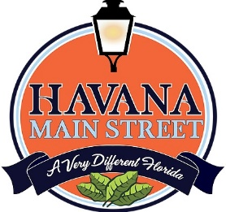
Please contact Ann Kozeliski, Executive Director, Havana Main Street, Havana, FL 32333 with any questions at 850-755-2999 or at ann.havanamainstreet@gmail.com and visit www.HavanaMainStreet.com and Facebook page for updates.

