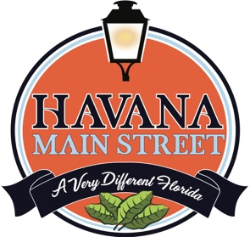

HAVANA LAWNMOWER PARADE

SATURDAY DECEMBER 10th

ENTRY FORM
Parade will be in downtown historic Havana on Dec. 10th at 1p. The starting point is the park by the library where 6th Avenue and 1st Street NE intersect.

For more info, contact Nancy Saunders at BlackCrowLLC@yahoo.com or at 850-567-4281.

NAME___________________________________________________

EMAIL__________________________________________________

PHONE _________________________________________________

ADDRESS _______________________________________________________

Type of entry:
_____decorated lawnmower
_____decorated golf cart
_____decorated tractor
_____decorated ATV
_____band
_____performing group
_____other (must specify:

________________________________________________________

PRIZES TO BE AWARDED
Entry forms can be mailed to Havana Main Street
PO Box 346, Havana, FL 32333 or Emailed to BlackCrowLLC@yahoo.com.

